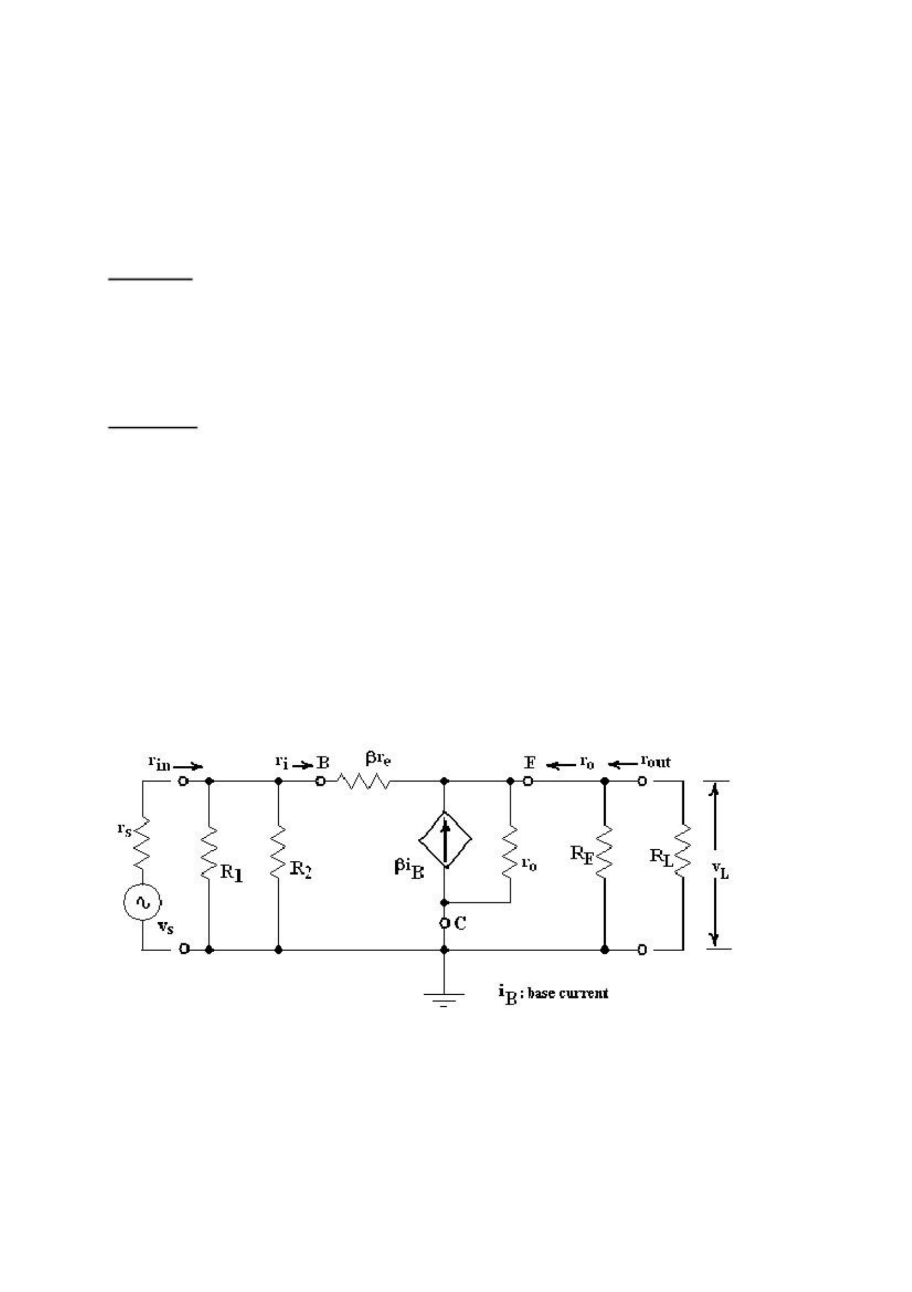**Başkent University**

1

**Department of Electrical and Electronics Engineering**

**EEM 214 Electronics I**

**Experiment 9**

**COMMON-COLLECTOR (EMITTER FOLLOWER) AMPLIFIER**

***Aim:***

**1.** To measure the open-circuit voltage gain, input resistance and output resistance of common-collector amplifier.

**2.** To demonstrate the use of the common-collector as a buffer between a high impedance source and a low impedance load.

***Theory:***

Common-collector or emitter follower amplifier is an important small signal amplifier configuration of the BJTs. It is very useful one because it has very high input resistance, high current gain, very small output resistance, and approximately unity voltage gain. The high input resistance and low output resistance make the emitter follower an ideal buffer between a high impedance source and a low impedance load. A buffer is any circuit that keeps the source from being affected by a load. For example, a common-emitter amplifier with a 10 KΩ output resistance could not provide very much voltage gain to a 50 Ω load resistor.

The following small-signal AC equivalent circuit can be used to calculate the gain, input resistance, and output resistance of the common-collector amplifier of Figure 2. Note that the current-controlled currnet source in Figure 1 is pointing down, like that of the common- emitter amplifier. However, the load in this case is in parallel with the emitter resistor, so the output voltage is in phase with the input voltage.

**Figure 1**

The open-circuit voltage gain AV of the emitter-follower amplifier can be found using the above small-signal ac equivalent circuit

and also the input resistance, rin, and the output resistance, rout, of the emitter-follower amplifier can be found by that equivalent circuit.

1

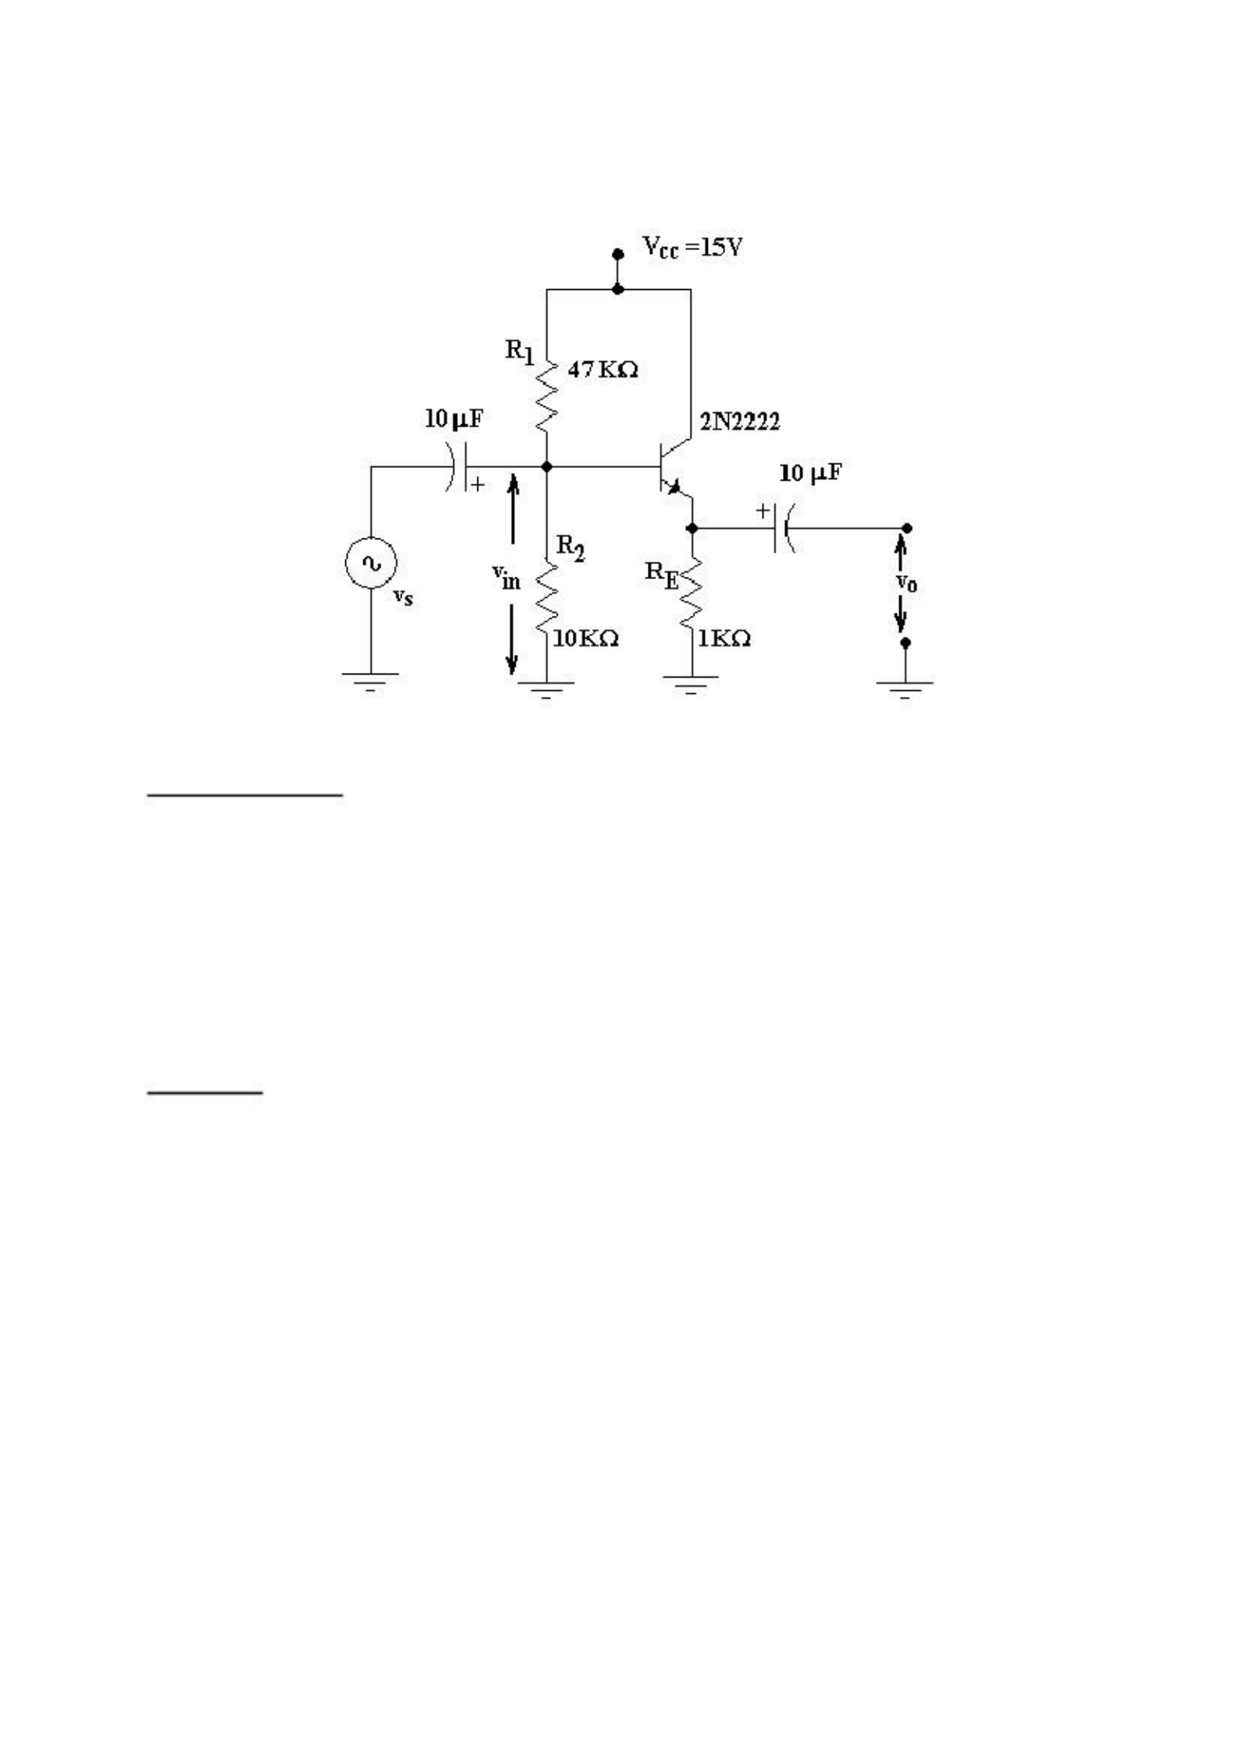

2

**BC238B**

**Figure 2**

***Preliminary Work:***

**1.** Find DC operating point of the circuit in Figure 2**.**

**2**. Establish small signal equivalent circuit in Figure 2.

**3.** Find the formulae of open-circuit voltage gain, AV1, the input resistance, rin, and the output resistance, rout, using the small-signal AC equivalent circuit of Figure 2, in Figure 1.

**4.** Find the open-circuit voltage gain, AV1, the input resistance, rin, and the output resistance, rout, of the emitter follower circuit in Figure 2.

***Experimental Work:***

**1.** Construct the circuit in Figure 2.

**2.** Adjust the signal generator’s frequency set to 10 KHz and have a sine wave with vO=0.1 VP-P. Measure and record the input voltage vin (including the phase relationship between vin and vO). These will be used to calculate the open-circuit voltage gain, AV1.

**Vin =**

**3.** To measure the output resistance, rout, of the common-collector amplifier, connect a 200 Ω potentiometer connected as a rheostat between the output coupling capacitor and ground. Adjust this potentiometer until vO is 50 mVP-P (one half of the normal 0.1 V output) Remove the potentiometer and measure its resistance. By the voltage divider rule, this resistance equals the output resistance of the amplifier.

**rout =**

2

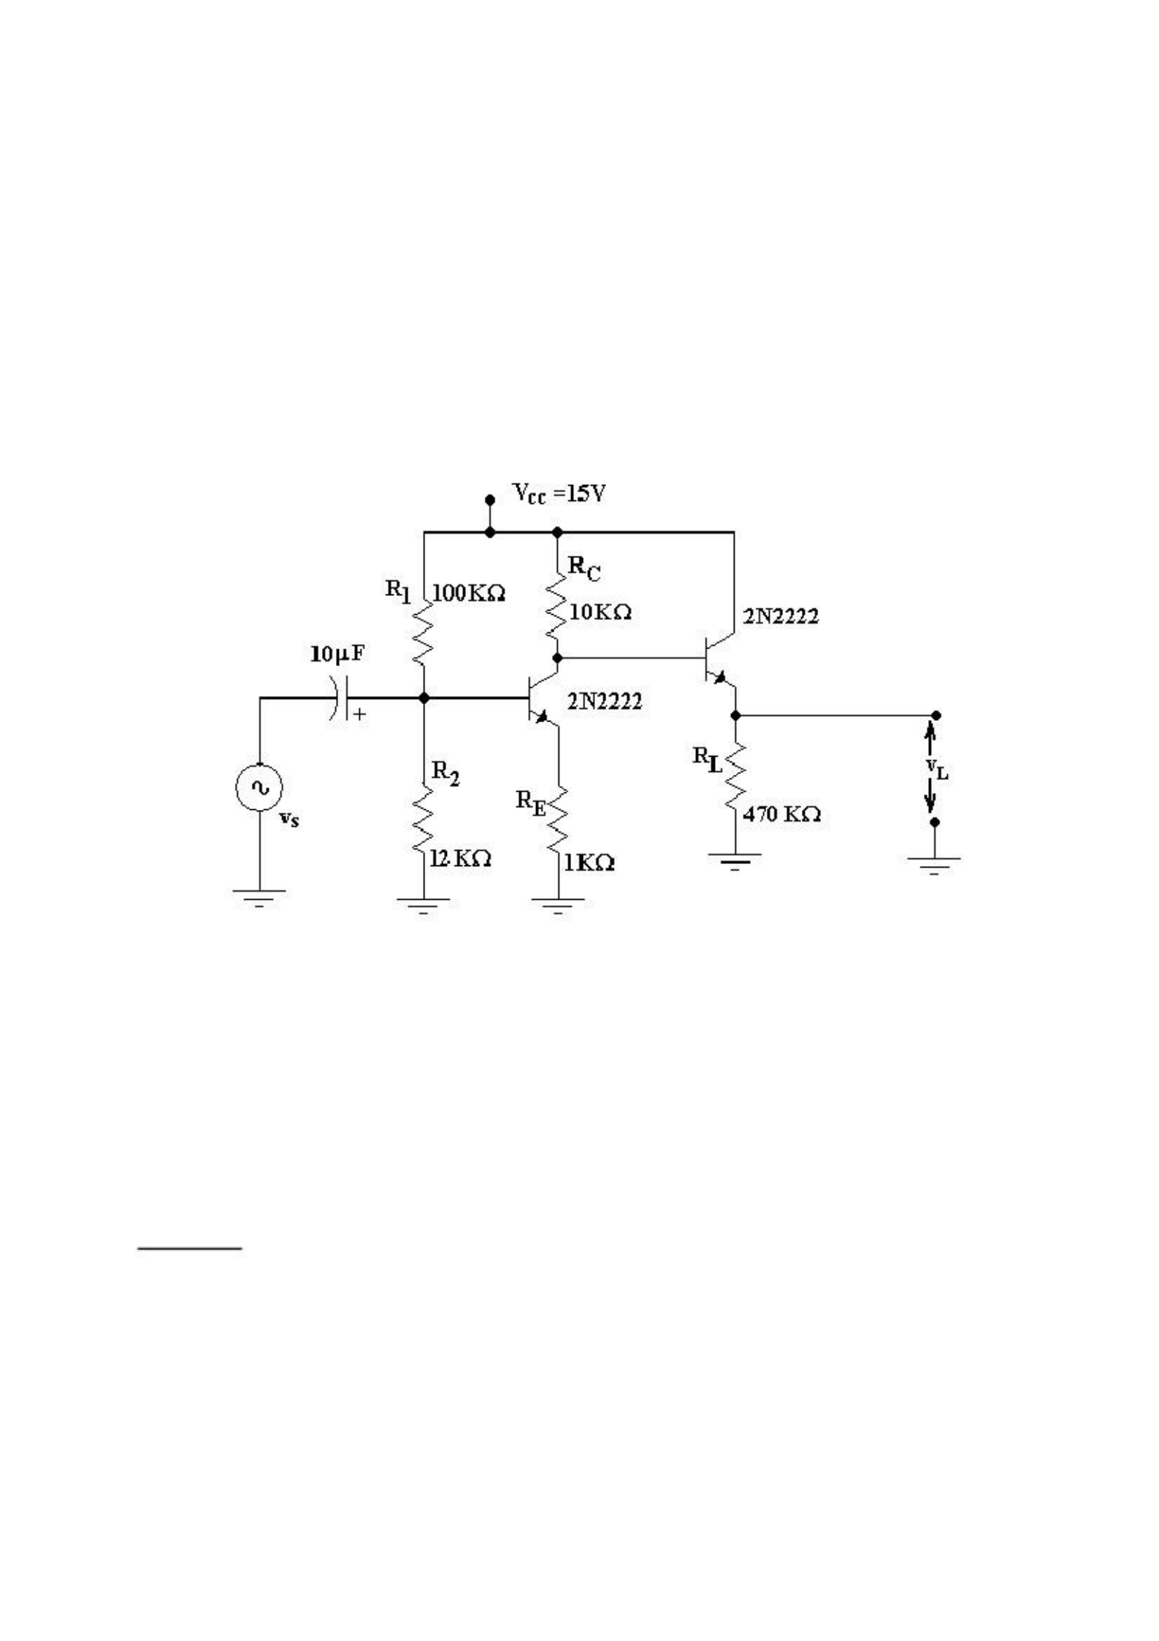**4.** To measure the input resistance, rin, of the common-collector amplifier, insert a 50 KΩ potentiometer connected as a rheostat between (in series with) the input coupling capacitor and the signal generator. Adjust this potentiometer until vO=50 mVP-P (one half of the normal 0.1 V output). Remove the potentiometer and measure its resistance. By the voltage divider rule, this resistance, less the signal generator’s internal resistance, rs, equals the input resistance of the common- collector amplifier.

3

**rin =**

**Figure 3**

**5**. To demonstrate the use of a common-collector stage to buffer a low impedance load from the high output resistance of the common-emitter amplifier, connect the circuit in Figure 3. (Note that the bias of the emitter follower stage is provided by the common-emitter amplifier’s collector voltage. This eliminates the need for extra coupling capacitors or voltage divider resistors)

**6.** Set Vin=0.1 VP-P @ 10 KHz. Measure and record VL . This value will be used to calculate the voltage gain from source-to-load, VL/VS.

**7.** Why do we adjust the load potentiometer to obtain the half of the normal output voltages at output while inspecting of input and output resistances? What is it related to?

**8.** What is rs, the internal resistance of signal generator ? Measure it.

**9.** Compare the calculated and measured results of rin and rout for Figure 2. You had to calculate them as a preliminary work.

3

**10.** As mentioned in step 6, we could bias the emitter follower by that configuration. How can it be? Explain the reason of biasing.

4

**11.** Is there any noticeable effect of emitter follower in Figure 3 on the voltage gain from source-to-load, VL/VS? If that exists, how much is it?

**12.** What is the function of an emitter follower in a circuit?

**13.** Obtain Pspice results for Figure 2 and 3. Compare simulation results with the experimental work.

***Equipment List:***

• 2 x BC238B npn transistor

• 15V DC power supply

• Signal generator

• Resistors; 1x100 KΩ, 1x47 KΩ, 1x12 KΩ, 1x10 KΩ, 1x1 KΩ, 1x470 Ω

• Capacitors; 2x10 µF (25V)

• Potantiometers; 1x50 KΩ, 1x200 Ω

• Dual channel oscilloscope

**Başkent University**

**Department of Electrical and Electronics Engineering**

**EEM 214 Electronics I Experiment 8**

**COMMON-COLLECTOR (EMITTER FOLLOWER) AMPLIFIER**

**Experiment Results:**

**Figure 2:**

**Figure 3:**

**Vin: Rout: Rin: VL:**

**Rs:**

**AV1:**

**AV2= VL/VS:**

Name, Surname: ID number:

Signature:

5